

**MSPM’S**

**Deogiri Institute of Engineering and Management Studies,**

**Aurangabad.**

**Department of Computer Science and Engineering**

Survey Based On

**Xiaomi Redmi Note 5 Pro**

Report Based On

**Manufactures of Processor**

**Subject: Computer Architecture and Organization**

Submitted By

**Sanket Shinde (26130)**

Under the Guidance of

**Asst.Prof. P.H. Durole**

Asst.Prof.Department of CSE

(Deogiri Institute of Engineering and Management Studies)

2019-2020

**Contents:**

1) Specification:

a. Hardware

b. Software

2) Reception

3) Colors

4) Sales

5) References

6) External Link

7) Price

8) Summary

**Xiaomi Redmi Note 5 Pro**

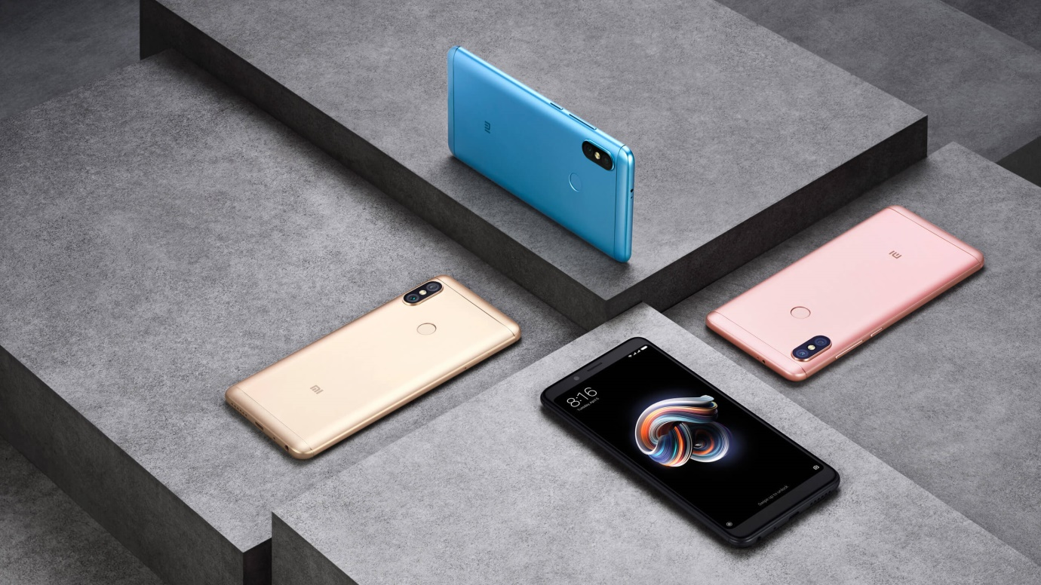

## Redmi Note 5 Pro Full Specifications

**General**

|  |  |
| --- | --- |
| Quick Charging | Yes |
| Operating System | Android v7.1.2 (Nougat) |
| Sim Slots | Dual SIM, GSM+GSM, Dual VoLTE |
| Model | Redmi Note 5 Pro |
| Launch Date | February 22, 2018 (Official) |
| Custom Ui | MIUI |
| Brand | Xiaomi |
| Sim Size | SIM1: Nano SIM2: Nano (Hybrid) |
| Network | 4G: Available (supports Indian bands) 3G: Available, 2G: Available |
| Fingerprint Sensor | Yes |

**Summary**

|  |  |
| --- | --- |
| Price In India | ₹ 11,100 |
| Performance | Octa core |
| Display | 5.99" (15.21 cm) |
| Storage | 64 GB |
| Camera | 12 MP + 5 MP |
| Battery | 4000 mAh |
| Ram | 4 GB |
| Launch Date In India | February 22, 2018 (Official) |

**Special Features**

|  |  |
| --- | --- |
| Fingerprint Sensor Position | Rear |
| Other Sensors | Light sensor, Proximity sensor, Accelerometer, Compass, Gyroscope |
| Fingerprint Sensor | Yes |

MULTIMEDIA

|  |  |
| --- | --- |
| Loudspeaker | Yes |
| Audio Jack | 3.5 mm |

**Performance**

|  |  |
| --- | --- |
| Chipset | Qualcomm Snapdragon 636 |
| Graphics | Adreno 509 |
| Processor | Octa core (1.8 GHz, Quad core, Kryo 260 + 1.6 GHz, Quad core, Kryo 260) |
| Architecture | 64 bit |
| Ram | 4 GB |

**Design**

|  |  |
| --- | --- |
| Build Material | Case: MetalBack: Metal |
| Thickness | 8 mm |
| Width | 75.4 mm |
| Weight | 181 grams |
| Height | 158.6 mm |
| Colours | Black, Gold, Red, Rose Gold, Lake Blue |

**Storage**

|  |  |
| --- | --- |
| User Available Storage | Up to 52.4 GB |
| Internal Memory | 64 GB |
| Expandable Memory | Yes Up to 128 GB |
| Usb Otg Support | Yes |

**Display**

|  |  |
| --- | --- |
| Screen size (inches) | 5.99 |
| Touchscreen | Yes |
| Resolution | 1080x2160 pixels |
| Protection type | Gorilla Glass |
| Aspect ratio | 18:9 |

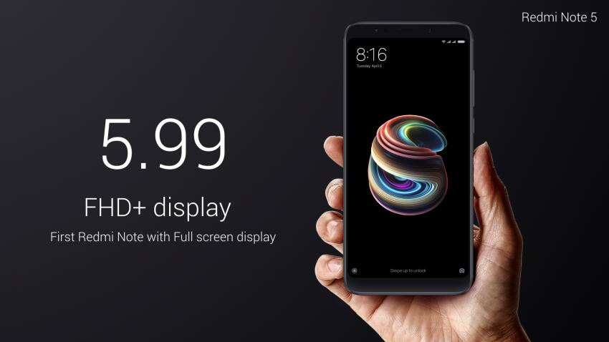

**Hardware**

|  |  |
| --- | --- |
| Processor | 1.8GHz octa-core |
| Processor make | Qualcomm Snapdragon 636 |
| RAM | 4GB |
| Internal storage | 64GB |
| Expandable storage | Yes |
| Expandable storage type | microSD |
| Expandable storage up to (GB) | 128 |

**Camera**

|  |  |
| --- | --- |
| Rear camera | 12-megapixel (f/2.2, 1.25-micron) + 5-megapixel (f/2.0, 1.12-micron) |
| Rear autofocus | Phase detection autofocus |
| Rear flash | LED |
| Front camera | 20-megapixel (f/2.2, 1.0-micron) |
| 0Front flash | LED |

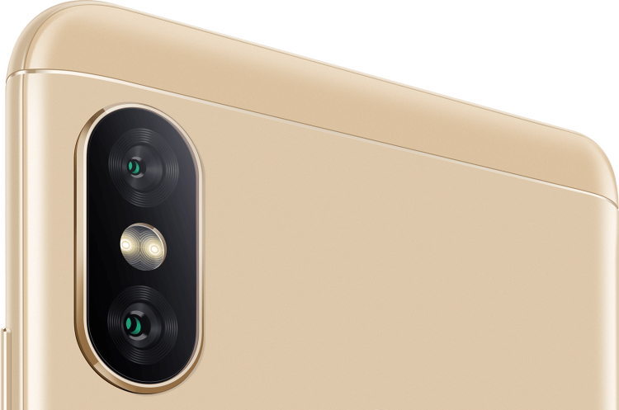

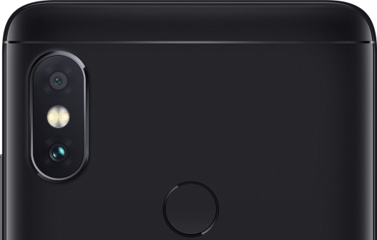

**Connectivity**

|  |  |
| --- | --- |
| Wi-Fi | Yes |
| Wi-Fi standards supported | 802.11 b/g/n/ac |
| GPS | Yes |
| Bluetooth | Yes, v 5.00 |
| NFC | No |
| Infrared | No |
| USB OTG | Yes |
| Micro-USB | Yes |
| Headphones | 3.5mm |
| FM | Yes |
| Number of SIMs | 2 |
| Wi-Fi Direct | Yes |
|  |  |
| **SIM 1** | |
| SIM Type | Nano-SIM |
| GSM/CDMA | GSM |
| 3G | Yes |
| 4G/ LTE | Yes |
|  |  |
| **SIM 2** | |
| SIM Type | Nano-SIM |
| GSM/CDMA | GSM |
| 3G/4G /LTE | Yes |

**Sensors**

|  |  |
| --- | --- |
| Face unlock | Yes |
| 3D face recognition | No |
| Fingerprint sensor | Yes |
| Compass/ Magnetometer | Yes |
| Proximity sensor | Yes |
| Accelerometer | Yes |
| Ambient light sensor | Yes |
| Gyroscope | Yes |
| Barometer | No |
| Temperature sensor | No |

**Specification:**

### Hardware

The Redmi Note 5 (Redmi Note 5 Pro Global) runs on Snapdragon636 processor.

It is a 64 bit architecture based chipset that has 8x Qualcomm® Kryo™ 260 CPUs with clock speed up to 1.8 GHz that supports Qualcomm® Adreno™ 509 GPU. This chipset is able to render FHD+ (18:9) display screen.

It comes with 5.99" full HD+ display, that has an 18:9 aspect ratio, the screen on the Redmi Note 5 has a screen-to-body ratio of 77%. The screen on the device comes with multi-touch support and uses a 2.5 curved glass screen for ultra clarity.

The Redmi Note 5 has a ppt rating of 403 and a maximum resolution of 1080x2160, the LCD IPS screen allows for smooth & accurate scrolling.

The main dual-camera setup at the rear of the Redmi Note 5 is located, unlike its predecessors, at the top-left corner on a protruding camera bump that resembles the one present on the iPhone X.

It is composed by a 12 MP image sensor plus a 5 MP depth sensor used in portrait mode to have bokeh effect in pictures. The 13 megapixel (India: 20MP) front facing camera features a front flash light rated for 4500K color temperatures as claimed by the company.

Redmi Note 5 comes with 3GB, 4GB or 6GB of RAM and 32GB or 64GB expandable storage memory.

**Software:**

Redmi Note 5 (China) runs on MIUI 10 based on Android Oreo 8.1.0. Redmi note 5 pro (India) and Redmi Note 5 (Global) runs on MIUI 10.3.1 stable based on Android Pie 9.0

**Reception:**

Redmi Note 5 received mostly positive reviews. TechRadar called it the best budget smartphone in the market and rated it 4/5. However lack of NFC and USB type C port, as well as the camera bump and inclusion of advertisements in the UI has been criticised.

**Sales:**

On 22 February 2018, in the first sale of the phone, the Indian division of Xiaomi claimed to had sold more than 300,000 Redmi Note 5 (Redmi 5 Plus) and Redmi Note 5 Pro units in less than three minutes and called it the biggest sale in the Indian history of smartphones.

**Colors:**

Redmi Note 5 is available in 5 colors:

1. Lake Blue
2. Rose Gold
3. Gold
4. Black
5. Red

The most popular of the color being Lake Blue, which was an instant hit among the users. Red is the next best; it was introduced at a later date.

External Links :

* [Official Redmi Note 5 website](https://www.mi.com/in/redmi-note5/)
* [Hidden Features Of Xiaomi Redmi Note 5 Pro](https://myg.in/blog/post/hidden-features-of-xiaomi-redmi-note-5-pro/)

**XIAOMI REDMI NOTE 5 PRO DETAILS**

**Buy For**

* Great configuration
* Excellent cameras
* Massive storage
* Good battery backup

**Beware of**

* No 4K video recording

**Verdict**

The Redmi Note 5 Pro is one of the premium smartphones that excel in almost every department. It is equipped with a wide range of strong features. The configuration is powerful to ensure a lag-free performance. The cameras are excellent and assist in capturing excellent images. Moreover, a massive storage make the device a delightful option in this price range.

The Xiaomi Note 5 Pro is hands down a great phone. It has a powerful processor and a good camera, not just on paper but in experience as well. The FHD+ display in an 18:9 aspect ratio is an added perk. The device comes in two storage variants of 4GB RAM and 64GB internal storage at Rs 13,999, which is dirt cheap for the kind of specs it offers.

There is also a 6GB RAM variant that comes at Rs 16,999, making it the first Xiaomi Note phone to have 6GB RAM variant. Personally, we feel, 4GB will be enough for a casual user, but for those who want extra, even this variant doesn’t qualify as over-priced. With so many things going for it, it’s hard but to not absolutely recommend the Note 5 Pro. Competition better up their game as Xiaomi with Note 5 Pro clearly has

**The best Note from Xiaomi**

**Display and Design**

The Xiaomi Redmi Note 5 Pro comes with a metallic body and has a thin-bezel design. It is available in Black, Gold, Rose Gold and Lake Blue colour options. Just below the rear camera module, a fingerprint scanner has been added for your convenience. The device sports a 5.99-inch IPS LCD full HD+ display, which exhibits an excellent pixel density of 403 PPI. It has the Corning Gorilla Glass that will protect it from minor scratches.

Given the obsession of the smartphone world with the 18:9 aspect ratio of the display Xiaomi too has incorporated this for the [Redmi 5 Pro](https://www.gadgetsnow.com/mobile-phones/Xiaomi-Redmi-Note-5-Pro). But this isn’t the first Xiaomi phone to come with a bezel-less design in India as it had introduced this feature with its flagship device the Mi Mix 2 last year. However, with the Redmi 5 Pro, now it won’t burn a hole in your pocket. Due to the bigger display, the capacitive keys are now on-screen keys.  
  
The front is as usual dominated by the display along with the selfie camera, earpiece and the usual array of sensors on the top edge, with a layer of 2.5D Corning Gorilla Glass on the top with rounded display corners. The curves make the phone easy to hold and facilitate smooth operation, despite sporting a 5.99-inch screen size.

Turn the smartphone around and you will first see a vertically placed [iPhone X](https://www.gadgetsnow.com/mobile-phones/Apple-iPhone-X) like rear camera setup, where the LED flash is housed in between the two lenses. Frankly, this is not the first time when an Apple design feature has made its way to other smartphones. Remember when the dual rear camera setup of the [iPhone 7 Plus](https://www.gadgetsnow.com/mobile-phones/Apple-iPhone-7-Plus) was unveiled, how many handset makers got "inspired" by the design?

Moving on, the back panel also has a centrally placed fingerprint sensor and the Mi branding below it. The handset comes with a micro-USB charging port (we fail to understand why) that is placed at the bottom, along with 3.5mm audio jack and the mono speaker. There's a volume rocker and power button on the right, while the left side has a SIM card tray. The top of smartphone has the IR blaster that lets it control devices such as a TV.

Coming to the display, the [Xiaomi Redmi Note 5 Pro](https://www.gadgetsnow.com/mobile-phones/Xiaomi-Redmi-Note-5-Pro) has a 5.99-inch screen with a FHD+ resolution of 2160x1080p. The display comes with features such as Reading mode, which reduces the blue light emissions; Schedule that lets you customize the period of this reading mode; Contrast and colour selection and text size options. The images were quite sharp and we did not see any pixelization. The sunlight legibility is not one of the best suits of the device and we also felt the display looks slightly dimmer, when viewed from a certain angle.  
  
Overall, we can say we did not have any complaints with the slim body design and is definitely going to grab some attention, even if it’s just for the rear camera panel.

**Battery and Connectivity**

The Xiaomi Redmi Note 5 Pro has a 4,000mAh Li-Polymer battery, which supports quick charging. It keeps the show running for long hours and can be charged at a lightning fast speed. As far as the connectivity is concerned, the device offers a wide range of options such as - mobile hotspot, Bluetooth, GPS, micro USB, Wi-Fi 802.11 and 4G with VoLTE.

**Configuration and OS**

Moving to the configuration, the Xiaomi Redmi Note 5 Pro is equipped with two Kryo 260 quad-core processor having a 1.8GHz and 1.6GHz clock speed. The processor is placed on a Qualcomm Snapdragon 636 chipset and it is coupled with a 4GB RAM. The combination is further assisted by an Adreno 509 GPU. Hence, the smartphone is perfect for gaming and heavy multitasking. It runs on Android v7.1.2 (Nougat) operating system and is skinned with the MIUI.

**Camera and Performance**

The Xiaomi Redmi Note 5 Pro is armed with a dual-primary camera setup (12MP + 5MP). At the front, a 20MP lens with an Exmor RS sensor. It can also record full HD videos at 30 fps. An LED flash has also been provided along with the front camera, that makes sure that you can make video calls at night. In terms of storage, it gets 64GB inbuilt storage and you can increase it up to 128GB by using a memory card.

Let’s talk about the specs of the device as it comes with a noteworthy feature. Debuting along with the Xiaomi Redmi 5 Pro is the Qualcomm Snapdragon 636 processor, making it the first smartphone in the world to be powered by it. This new chipset features the newest Kyro technology, claimed to be seen in the 800-series chipset. Apart from this, the Note 5 Pro has 4GB RAM and 64GB internal storage.  
  
The device runs Xiaomi's MIUI 9 skin based on Android 7.1.1 Nougat, and should hopefully receive an Oreo-based update as all major launches of this year now are expected to come with the latest operating system. The MIUI 9, like the typical Xiaomi UI, has no app drawer and therefore all apps are placed on multiple home-screens. It comes with an app lock feature and dual apps space customized theme option. The leftmost home screen comes with quick cards that show the frequently used features and information. It is placed in the form of cards, similar to Today's page in iOS, that show shortcuts, calendar, take a note and more. This can obviously be customized as per the user and comes in quite handy once you start depending on it.

One thing that we must point out is that even though the handset has a third-party theme support, these apps are not yet optimized for the 18:9 aspect ratio of the display. There is a blank black patch that comes on the lock screen if you select any app and it surely gets on your nerves after a point. When we asked Xiaomi about this, they said, "Starting this month, all official themes from [Mi India](https://www.gadgetsnow.com/topic/Mi-India) will be adapted to 18:9 aspect ratio. Also, third-party theme developers are being pushed to adopt their themes for 18:9 phones."

We ran Antutu and GeekBench 4 tests on our device. While the phone scored 100031 in Antutu Benchmarks, the single-core and multi-core scores on GeekBench 4 were 1772 and 4227 respectively.  
  
During our testing, we found the overall performance of the Xiaomi Note 5 Pro to be simply incredible. The phone handled multi-tasking of random app in a smooth lag-free way. We did not encounter any frame freezing of any kind. Both the call quality and the Audio quality are also quite good. The issue persists with the speaker placed at the bottom as the sound gets muffled when the device is placed in a landscape mode.  
  
The Xiaomi Redmi 5 Pro is backed by a 4000mAh battery that easily lasted us for more than a day of average use that included playing games and browsing social media apps, with Wi-Fi turned on.

Moving on to the cameras, the Xiaomi Note 5 Pro comes with a -- iPhone-look-alike -- dual rear camera setup of 12MP+5MP RGB sensors. The primary 12MP camera has a 1.25µm sensor and a f/2.2, while the secondary camera has 1.12µm sensor and f/2.0. As per Xiaomi, the secondary camera comes in handy for depth sensing in the portrait mode as well as capturing 'additional information' in low-light shots. On the front, the device a whopping 20MP camera, not seen something on a Xiaomi device before. This front camera comes equipped with Beautify 4.0 AI algorithm and a dedicated selfie-light, clearly marking its move to capture the selfie-crazed generation of the country.

The camera app is pretty simple with options to make a video, a short video (it is preset to 10 seconds), capture a picture in square mode, portrait mode, panorama and manual mode. It also has native Instagram-like filters for the users.

## XIAOMI REDMI NOTE 5 PRO PRICE IN INDIA

Xiaomi Redmi Note 5 Pro price in India starts from Rs. 10,426. The lowest price of Xiaomi Redmi Note 5 Pro is Rs. 10,426 at paytmmall.com. This is 4 GB RAM / 64 GB internal storage base variant of Xiaomi Redmi Note 5 Pro which is available in Black, Gold, Red, Rose Gold, Lake Blue colour.



**Redmi Note 5 Pro Summary**

The Xiaomi Redmi Note 5 Pro features a metal chassis and a 5.99-inch, full-HD+ display with Gorilla Glass. The design is a bit plain but the build and finish is good. The display also has very good levels of brightness and colours are nice and punchy. This is the first phone to feature Qualcomm's Snapdragon 636 SoC, which offers plenty of power for gaming and heavy apps. You can choose between either 4GB or 6GB of RAM but the storage is the same, at 64GB. Camera performance is also good. The Note 5 Pro features a Portrait mode too for the front and rear camera, which works well. Battery life is also very good, as the phone easily lasts for an entire day on a single charge and fast charging is also supported although you'll have to buy a fast charger separately.



CERTIFICATE

This is to Certify that **Mr. Sanket Shinde** had Successfully Completed

his Survey Based Redmi Note 5 Pro Report on Manufactures of Processor on date 6 /09 /2019 .

Name Of Guide Prof.P.H. Durole

Asst.Prof.Department of CSE.